**Module 3:- Hardware**

**Section 1: Multiple Choice Answers**

1. **What is the primary function of a router in a computer network?**  
   **c)** Forwarding data packets between networks
2. **What is the purpose of DNS (Domain Name System) in a computer network?**  
   **c)** Converting domain names to IP addresses
3. **What type of network topology uses a centralized hub or switch to connect all devices?**  
   **a)** Star
4. **Which network protocol is commonly used for securely accessing and transferring files over a network?**  
   **b)** FTP

**Section 2: True or False**

1. **True or False: A firewall is a hardware or software-based security system that monitors and controls incoming and outgoing network traffic based on predetermined security rules.**  
   **True**
2. **True or False: DHCP (Dynamic Host Configuration Protocol) assigns static IP addresses to network devices automatically.**  
   **False** (DHCP assigns **dynamic** IP addresses, not static ones.)
3. **True or False: VLANs (Virtual Local Area Networks) enable network segmentation by dividing a single physical network into multiple logical networks.**

**True**

**Section 3: Short Answer**

1. **Explain the difference between a hub and a switch in a computer network.**
   * A **hub** broadcasts data to all connected devices, causing network congestion.
   * A **switch** intelligently forwards data only to the intended recipient, improving efficiency and speed.
2. **Describe the process of troubleshooting network connectivity issues.**
   * Check physical connections (cables, power, Wi-Fi signal).
   * Restart the modem/router and affected devices.
   * Verify IP configuration using ipconfig (Windows) or ifconfig (Linux/Mac).
   * Ping the network gateway or another device to check connectivity.
   * Disable firewalls or security software temporarily to rule out interference.
   * Reset network settings if necessary.

**Section 4: Practical Application**

1. **Demonstrate how to configure a wireless router's security settings to enhance network security.**

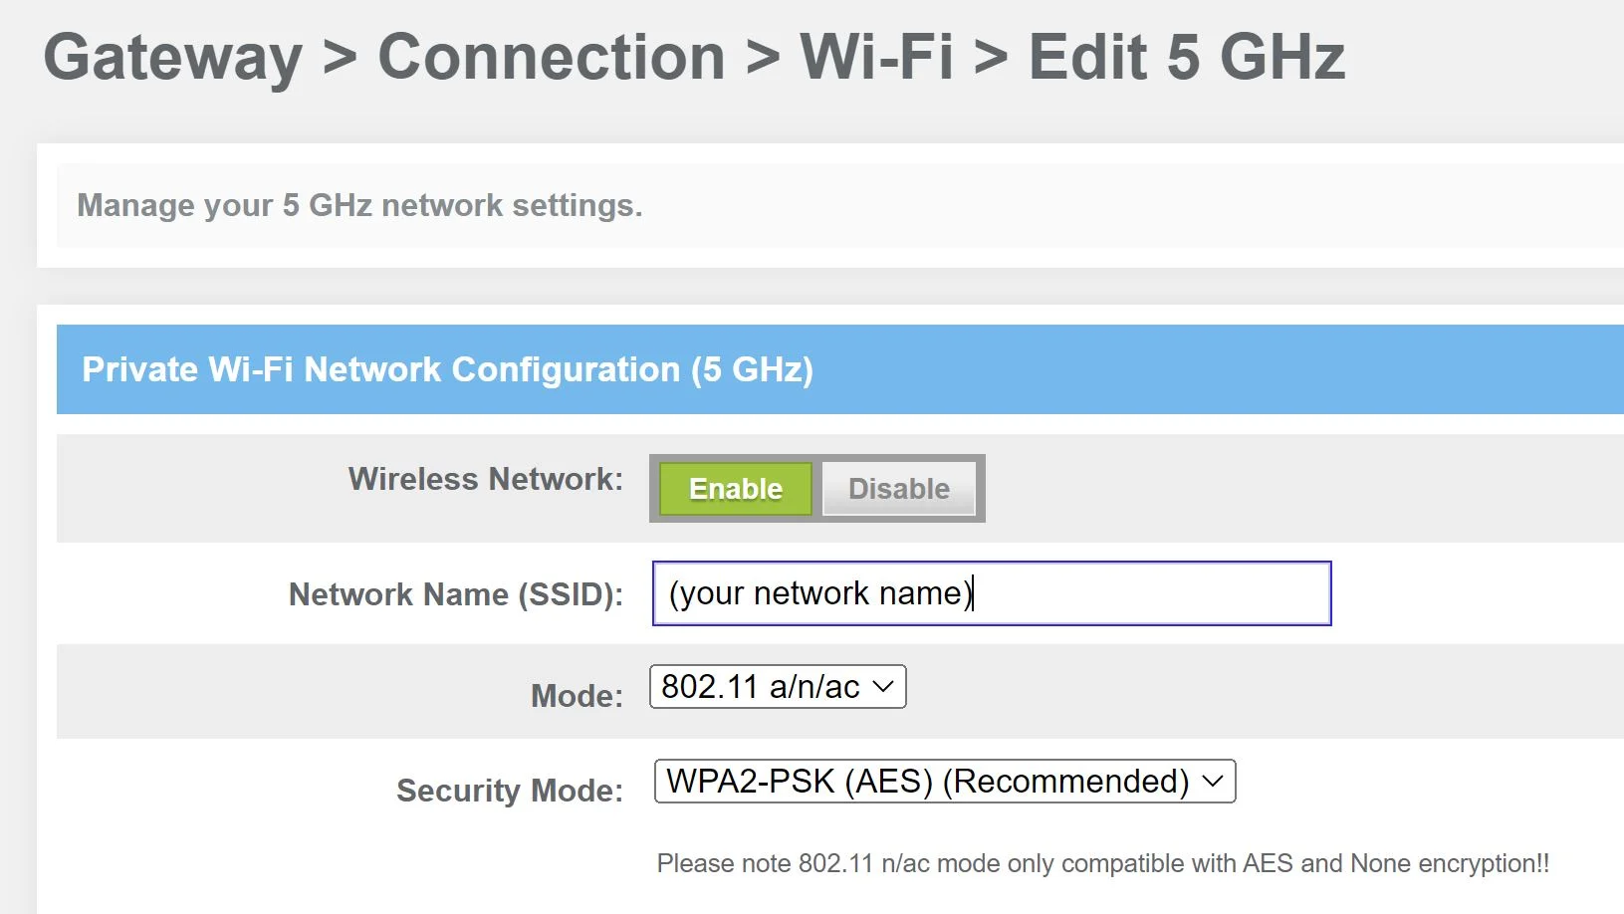

* Access the router’s admin panel via its IP address (e.g., 192.168.1.1).
* Set a **strong WPA3 or WPA2 password** for Wi-Fi.
* Change the **default SSID** (network name) to a unique one.
* **Disable WPS** (Wi-Fi Protected Setup) to prevent unauthorized access.
* Enable **MAC address filtering** to allow only trusted devices.
* Update the router’s **firmware** regularly.

**Section 5: Essay**

1. **Discuss the importance of network documentation and provide examples of information that should be documented.**

* **Importance:**
  + Helps in troubleshooting and future network expansion.
  + Ensures consistency in network management.
  + Improves security by tracking changes and access controls.
* **Examples of information to document:**
  + Network topology diagrams.
  + IP address allocations and device names.
  + Router and switch configurations.
  + Security settings and access control lists.
  + Software and firmware versions.